***Business Intelligence and data visualization***

***Knime Project***

***Diabetes***

*Made By:- Nikhil chawla(18csu140)*

*Nikhil Garg(18csu141)*

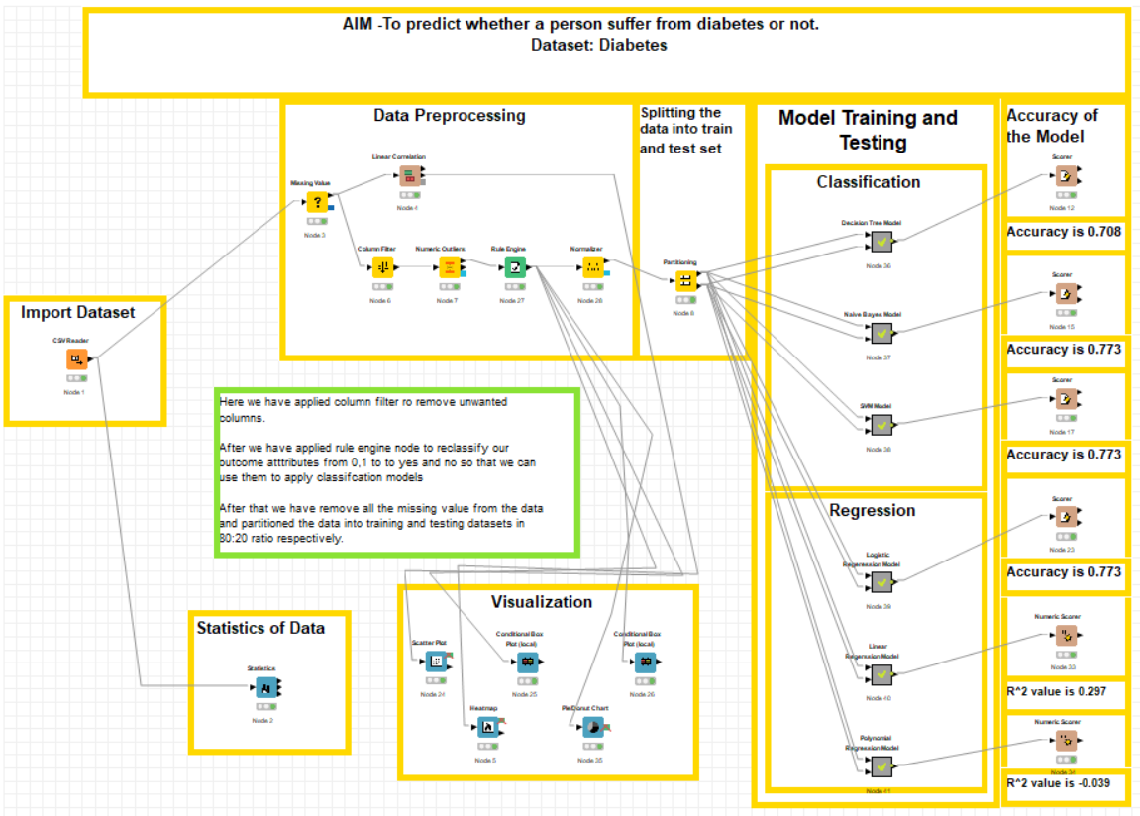

**Import Dataset:-**

In this we import the dataset Diabetes.csv

**Statistics of Data:-**

In this we are showing the statistics like mean , mode , standard deviation,etc of the dataset.

**Visualization:-**

In this we analyze the dataset by making the visualization like scatter plot , box plot , heat map , pie chart.

**Data Pre-processing:-**

1. In this we check for missing values.
2. Then we check for correlation of all the columns
3. Then we remove irrelevant columns then we consider the outcome column value “0” as “no diabetes” and “1” as “diabetes”.
4. Then we normalize the data of all the column.

**Splitting the data into testing and training**

**Model Testing And Training:-**

In this we are doing classification and regression techniques for prediction.

In **Classification** we are using decision tree , naïve bayes and svm classification method for prediction

In **Regression** we are using logistic regression , linear regression and polynomial regression method for prediction

**Accuracy:-**

In this we are checking the accuracy of all the model by the **Scorer** and  **Numeric Scorer Node.**